UML Diagram

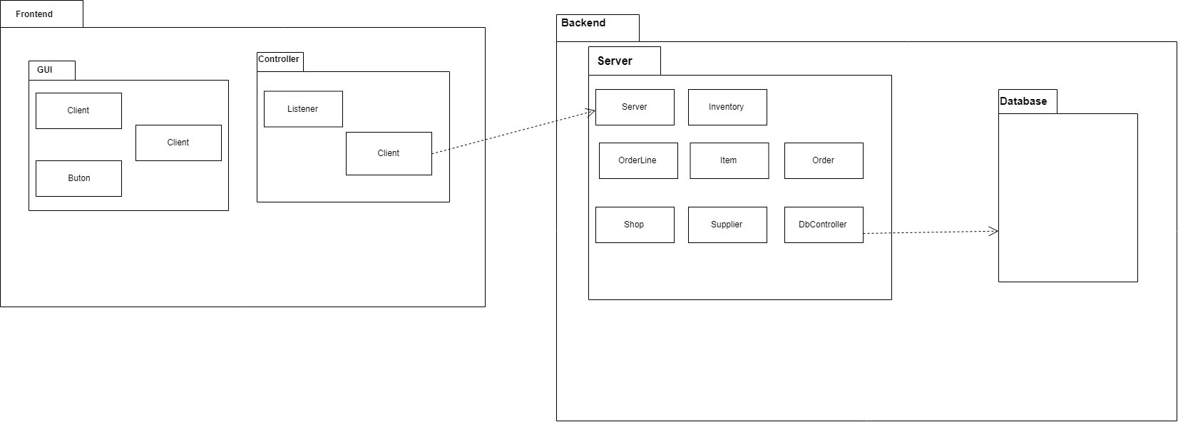Oscar Wong (30039354) and Jeremy Olea (30045602)

## Detailed Class Diagram of Frontend Package

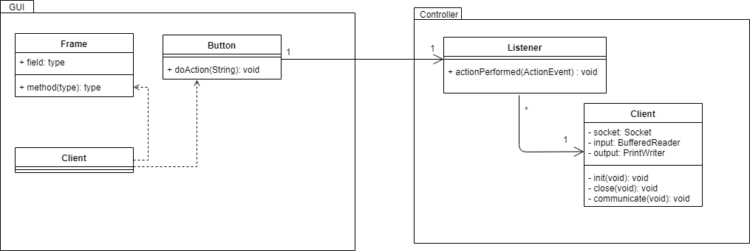

## Detailed Class Diagram of Backend Package

